
COIT20265-Networks and Information Security Project
Term 1, 2026
Assignment 1 –Project Proposal

Prepared by:
Suhartanto Tanuwijaya (12290667)
Dev Anand Suresh (12272597)
Sai Teja Akula (12228905)

Campus: Sydney and Melbourne
Unit Coordinator : Biplob Ray
Mentor : Dr. Ahmedi Azra
Table of Contents
Introduction 3
Project Background 3
Project Overview 3
Problem Statement 4
Project Objective 4
Project Management Overview 4
Project Approach 4
Project Schedule and WBS 6
Project Risk and Mitigation Plan 14
Project Budget Estimation 15
Project Scope 17
Project Methodology 18
Machine Learning Pipeline 18
Dataset Acquisition and Preprocessing 18
Data Acquisition 18
Data Preprocessing 19
Performance Measures 19
Baseline Model 19
Test Case 19
User Interface 19
Result and Analysis 19
Conclusion and Recommendation 19
Limitation 19
Recommendation 19
Delivered Technical Artefacts 20
Contributions 20
References 21

Introduction

Project Background
The rapid proliferation of Internet of Things (IoT) devices has transformed modern networks, creating highly interconnected environments across smart homes, healthcare, and industrial systems.
However, the resource-constrained nature of these devices and the massive volume of generated traffic have expanded the attack surface, introducing severe security vulnerabilities. Traditional signature-based Network Intrusion Detection Systems (NIDS) struggle to identify zero-day exploits and often fail to scale effectively in dynamic, heterogeneous IoT ecosystems.
In order to overcome these issues, this project proposes an intelligent solution that leverages supervised machine learning techniques to analyse network traffic and detect threats. This system generate real-time alerts and improve detection accuracy, providing a practical and adaptable approach to modern network security challenges.

Project Overview
Also, Google Colab will be used as the primary platform for training and evaluating the model due to its computational capabilities. Also, as user interface application, Tkinter in Python librar would be as consideration as well.
Moreover, Node-RED will be considered as an alternative platform to deploy the model in an IoT environment, enabling real-time data flow, visual dashboards, and automated alert generation.

Problem Statement
Based on conducted study by Abdallah et al (2022) , found there are couple of problem by implementing network intrusion detection system, which are as follow :
- High false alerts or alarm rate and high rate of malicious attacks are undetected
- Incoming New attacks need to be more attention needed by developing machine learning models for easier detection attacks.
- The client currently does not have an effective system to detect Denial-of-Service (DoS) attacks, which poses a significant risk to network availability and operational continuity.

Project Objective
A study has been conducted by Abdallah et al (2022) , the objective implementing network intrusion detection would be generate alerts and respond to suspicious behaviours. Then, according The University Of Queensland (2013) Benign has been described as normal unmaliciously flows.
The primary objective of this project is to design and develop a machine learning-based Network Intrusion Detection System capable of identifying malicious and Benign network traffic. The system will be practically demonstrated by generating real-time alerts and responding to detected threats. The solution aims to achieve at least 70% detection accuracy within an industrial IoT environment.

Project Management Overview
Moreover, project approaches ,organization structure , project schedules , WBS and estimation budget would be discussed further in this section.

Project Approach
The project will adopt an agile methodology, which supports iterative development, continuous feedback, and flexibility in handling changing requirements. The project will be divided into short development cycles (sprints), allowing incremental delivery of features such as data preprocessing, model training, and system integration.
Figure 1. Scrum Approach
Source: Ian Sommerville,2018
Figure 1 shows, project approach would be using Scrum since having limited time to completed this project and details processes has been shown in figure as well.

Project Schedule and WBS
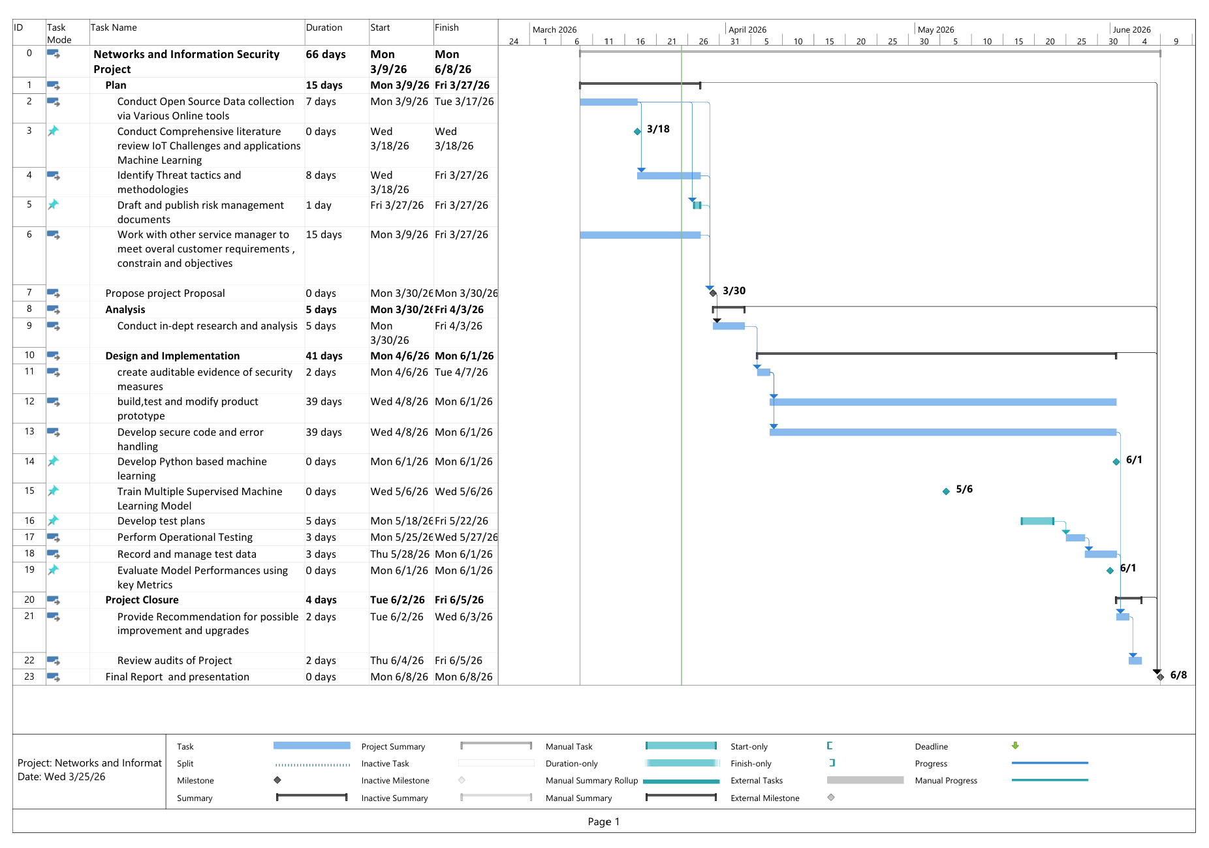
Figure 2 Gantt Chart
Figure 2 shows, project schedule has been visual by using Gantt chart including details as follow :
- Project Title : Drone Delivery System Project
- Start Date : Monday, 9 March 2026
- Finish Date : Monday, 8 June 2026
- Total Duration : 66 working days
- Project Calendar : Standard (Monday–Friday, 8 AM–5 PM)
- Number of Major Deliverables:
  - Conduct Comprehensive literature review IoT Challenges and applications Machine Learning
  - Propose Project Proposal
  - Develop Python based machine learning
  - Train Multiple Supervised Machine Learning Model
  - Evaluate Model Performances using key Metrics
  - Final Report and Presentation
- Number of Work Packages : 13 tasks (excluded milestones)
- Earliest Start Activity : Conduct Open Source Data collection via Various Online tools – 9 March 2026
- Latest Finish Activity : Review Audits and Project – 8 June 2026
- Longest Lead Activity : Develop secure code and error handling ( 39 working days)
- Estimated Project Completion : 66 Days

Role
Student Name | Role | Justification
Suhartanto Tanuwijaya and Dev Anand | Data Analyst | In order to be able conduct open source data collection , identify threat tactics , methodologies , dept research ,analysis and create auditable evidence of security measures, There are some skills, knowledges and abilities are needed for this role , as follow :  Knowledge :  - Understand network traffic analysis method  - Understand cyber threats and vulnerabilities  - Understand physical and logical network devices  - Understand to extract,analyze and use metadata  - Understand internet applications works and OSI model protocols  Abilities :  - Has critical thinking  - Ability to evaluate, analyse and synthesize large quantities of data into high quality products  Skills :  - Able to evaluate information for reliability ,validity and relevance  - Able to using multiple analytic tools such as WEKA.
Suhartanto , Dev Anand Suresh | Software Developer | In order to be able develop secure code and error handling, there are some skills, knowledges and abilities are needed for this role , as follow :  Knowledge :  - Understand computer programming principles  Abilities :  - Handle complex mathematical concepts  Skills :  - Able to using code analysis tools
Dev Anand and Sai Teja | IT Tester | To be able develop test plans,perform operational testing, record,manage test data and evaluate model performance using key metrics , there are some skills, knowledges and abilities are needed for this role , as follow :  Knowledge :  - Understand system testing and evaluation method  Abilities :  - Conducting test events  - Write test plans  Skills :  - Able to collect ,verify and validate test data
Sai Teja and Dev Anand | IT Project Manager | To be able draft and publish risk management documents, gather customer requirements , project objectives , propose project proposal, provide Recommendation for possible improvement , review audits of project and presentation included project report , there are some skills, knowledges and abilities are needed for this role , as follow :  Knowledge :  - Understand of risk management processes , standards and practices , including methods and mitigation risks.  - Understand resource management principles and techniques  - Understand organization objectives  Abilities :  - Perform risks management standards  Skills :  - Able to identify actions needed to improve relative to project goals or objectives
Suhartanto and Dev | Research and Development Specialist | To be able build ,test and modify prototype ,  there are some skills, knowledges and abilities are needed , as follow :  Knowledge :  - Understand cyber threat and vulnerability  - Understand computer networking concept, protocol and network security methodologies  - Understand penetration testing principle ,tools and techniques  Abilities :  - Produce technical document  - Identify system security issues based on analysis of vulnerability and configure data  Skills :  - Able to use scientific rules and methods to solve problem  - Able to apply information technologies into propose solution  - Able to create and utilize statistical model
Sai Teja and Dev Anand | Scrum Master | Responsible for managing Agile processes, facilitating sprint planning, removing obstacles, and ensuring effective collaboration among team members.
Table 1 Job Role Justification
Table 1 shows, Identified job roles of this project has been justified by showing needs of skills, knowledges and abilities to be able completed requirement tasks as shown in table 2.

Task
Task | Description | Deliverables
Work with other service managers to meet overall customer requirements, constraint and objectives | Identifies client requirements, constraint and objectives | - Identified objectives, needs and constraint
Identify threat tactics and methodologies | Identified data collection methods and dataset would be use . | - Data collection methods : Quantitative and secondary data sources
Conduct Open Source data collection via various online tools | Collecting network traffic dataset from credible sources and online | - Scatterplot Visual  - Table of attribute dataframe  - Table of evaluated attributes
Conduct in-dept research and analysis | Research and analysis indicators for malicious and normal network traffic | - Normal and malicious indicators
Draft and publish risk management documents | Provide and identifies project risks and mitigation plans | - Identified management risks and mitigation plans
Build , test and modify product prototypes using working models or theoretical models | Developed a python-based machine learning model and tested some test cases | - Prototype Machine Learning  - Test cases result  - Training machine learning model
Programming | Write source code machine learning by using python language | - Source code Machine learning Model
Record and manage test data | Prepare a dataset to be tested and documentation the test cases result | - Documentation  - Pilot , pre test and primary test dataset
Perform Operational Testing | A user who are testing prototype and developed machine learning model based on test cases instructions | - Test cases findings
Develop test plans to address specifications and requirements | Prepare scenarios testing to user or actor who are preform testing. | - Developed test cases
Create Auditable evidence of security measures | Prepare key indicator measurement of detection attacks | - Developed key indicators of detection
Provide Recommendation for possible improvement and upgrades | Provide next steps recommendation report to client or higher position executives | - Final report documentation  - Presentation
Review audits of projects | Provide performance evaluation team contribution | - Contribution reports
Table 2 Tasks Description and Deliverable
Table 2 shows, each identified task has been and described

Responsible Matrix
Task | Technical Lead | Reviewer
Identify threat tactics and methodologies | Suhartanto | Dev Anand
Conduct Open Source data collection via various online tools | Suhartanto | Dev Anand
Draft and publish risk management documents | Sai Teja | Dev Anand
Conduct in-dept research and analysis | Dev Anand | Suhartanto
Build , test and modify product prototypes using working models or theoretical models | Suhartanto | Dev Anand
Develop secure code and error handling | Dev Anand | Suhartanto
Record and manage test data | Sai Teja | Dev Anand
Perform Operational Testing | Sai Teja | Dev Anand
Develop test plans to address specifications and requirements | Dev Anand | Sai Teja
Create Auditable evidence of security measures | Dev Anand | Suhartanto
Provide Recommendation for possible improvement and upgrades | Sai Teja | Dev Anand
Review audits of projects | Sai Teja | Dev Anand
Table 3

Project Risk and Mitigation Plan
Risk ID | Risk | Mitigation
R001 | Project Data’s has been stolen or lost | Implement security mechanism such as data encryption and off-site/cloud backups with geographic redundancy.
R002 | Phishing email targeting employees | Provide staff training awareness and implement email filtering software
R003 | Cryptographic Weak | Apply strict cryptographic policy compliance checks and penalties for non-adherence.
R003 | Low model accuracy | Improve training data and use better algorithms
R004 | Data quality issues | Perform data preprocessing and validation
R005 | Integration issues between tools | Conduct early integration testing
R006 | Lack of team coordination | Use Agile meetings (daily stand-ups)
R007 | Overfitting of model | Apply cross-validation techniques
Table 4. Project Risk and Mitigation Plan
Table 4 shows, several project risks has been identified and mitigation plan has been created to able covering risks are happening.

Project Budget Estimation

Personnel
Resource | Justification | Cost/License
Data Analyst | 315 AUD for Technical lead and 157 AUD Reviewer | 472 AUD/day
Software Developer | 315 AUD for Technical lead and 157 AUD Reviewer | $472 AUD/day
Research and Development Specialist | $ 320 AUD Technical Lead and 160 AUD reviewer | $ 480 AUD/day
IT Tester | 273 AUD for technical Lead and 136 AUD as reviewer | 409 AUD/day
IT Project Manager & Scrum Master | No reviewer | $ 356 AUD /Day
Table 5. Personnel Cost and Justification
Table 5 shows, budget estimation of personnel according Seek.com including justification.

Paid Application
Resource | Justification | Cost/License
Google Colab Pro | Data has been captured , would be evaluate by using Google Colab Pro and training as well for create a new machine learning model  Google Colab Pro would provide better compute specification , which is it could able to machine training and evaluate data faster than free plan | $ 75.62 per month
Table 6. Paid Application Cost and Justification
Table 6 shows, budget estimation for paid application including justification.

Unpaid Application
Resource | Justification | Cost/License
Wireshark | This application its needed while testing the machine learning has been developed to able  to able capture network traffic , which it would be use as input. | Free, GNU GPL Open Source
Microsoft Project | This application its needed  To improve flexibility of managing schedule and managerial aspect of project | Free
Weka | This application its need to able identify and analysis attributes, and classify into specific type of network traffic from dataset has been collected , Including threat and warning key indicators. | Free
Node-Red | This application its need  Needed as alternative option and able to create IoT web smart application. | Free
Table 7.. Unpaid Application Cost and Justification
Table 7 shows, free application will be used for development of machine learning Network Intrusion Detection Systems (NIDS). Therefore,total budget for all personnel to completed the project in 66 days would be $ 59,347 AUD. Therefore, estimation total budget would be $ 65.,760 AUD For tools and resources of this project. There are no cost for chosen unpaid application resources and it is all available in Internet.

Project Scope
The project will be aimed based on client needs and wants by build an application with supported supervised machine learning model who able to network intrusions detections , which is either normal or malicious traffics. Project methods , machine learning model overview and managerial implication would be discussed as well , including budget estimation,project risks , mitigation plan, project organization structure ,project approaches ,project schedule and WBS.

Project Methodology
Discussion regarding data collection and machine learning overview would be discussed in further in this section .

Machine Learning Pipeline
The machine learning model will be implemented using supervised learning techniques and the implementation process is as follows:
- Dataset Acquisition : Download captured dataset .
2. Data Pre-processing - Cleaning and transforming raw data, handling missing values, and normalising features by using Panda and Numpy.
2) Feature/ Attribute Selection - Identifying the most relevant attributes that contribute to accurate intrusion detection by using WEKA evaluator attribute model.
3) Model Training – Designing and Applying machine learning classification algorithm Decision Tree model using Python in Google Colab.
4) Model Evaluation - Testing the model using ,test cases , validation datasets and evaluating performance based on accuracy, precision, and recall.
5) Deployment - Integrating the trained model into a real-time environment including User Interface
6 ) Prediction Output - Integrating the trained model into a real-time environment.

Dataset Acquisition and Preprocessing

Data Acquisition
The project utilises publicly available datasets, including UNSW-NB15 and NSL-KDD, which contain labelled network traffic data for both normal and malicious activities. These datasets provide a wide range of attack types and realistic network scenarios for training and testing the machine learning model. Using these benchmark datasets ensures reliability and enables accurate evaluation of intrusion detection performance.

Data Preprocessing
- Data Attribute Evaluator
  - Method : BestFirsth

Performance Measures

- Python Library :

- Confusion Matrix
- Measures Equation :
  - Accuracy

  - Precision
  - Recall
  - False-Positive rate

Baseline Model
- Model Classification Algorithm

Test Case

User Interface

Result and Analysis
Conducted Deep Analysis and Research , several findings as follow :
- Using KDD_Test dataset
- Select attribute evaluator : WrapperSubsetEval , Method evaluator : Bestfirst Method and

Decision Tree Diagram KDD_Test dataset

FTP : File Transfer Protocol
Gopher protocol: distributed document ( search and retrieval )
Exploit -> vulnerability by penetration testing

Conclusion and Recommendation

Limitation

Recommendation
<THIS SECTION IS ONLY NEEDED IN FINAL REPORT – NOT NEEDED IN DRAFT REPORT.
Provide recommendations to the client on the next steps they should take with the project. This may include: tasks that you planned to complete but did not; implementing and testing features that you only designed; adding components which were out of scope of the original project; ideas you obtained during the project that you think would be valuable to design/build if more time was available. >

Delivered Technical Artefacts
<This Word doc does not include all your technical artefacts. Instead, you can include your detailed design documentation in separate files, and then combine them all together into a single PDF and ZIP. See the Moodle site for instructions. Use the table below to list the technical artefacts delivered. The table contains some examples – delete them before entering your technical artefacts.>
Name | File | Description | PDF?

Contributions
<For each student in the group, give the key contributions they made and the technical artefacts that they led. Include an approximate percentage contribution to the entire project. The percentage must sum to 100%. Focus is on the technical artefacts, not the project management artefacts (such as Project Plan, Progress Reports). Typically, only one student is a technical lead on an artefact, but in some instances there may be two students.>
Student Name | Percent | Summary of Contributions | Technical Lead on Artefacts

References
Abdallah, E. E., Eleisah, W. & Otoom, A. F., 2022. Intrusion Detection Systems using Supervised Machine Learning Techniques: A survey. Procedia Computer Science, Volume 201, pp. 205-212.
Almasir, Y. et al., 2025. Ransomware Detection on IoT Edge Using Optimized Deep Representation Learning. TechRxiv.
McHungh, J., 2000. Testing intrusion detection systems: a critique of the 1998 and 1999 darpa intrusion detection system evaluations as performed by lincoln laboratory. ACM Transactions on Information and System Security, Volume 3, pp. 262-294.
The University of Queensland, 2013. Machine Learning-Based NIDS Datasets. [Online]
Available at: https://staff.itee.uq.edu.au/marius/NIDS_datasets/

